# PREFACE

This project report has been developed especially for you computerization and management required in **“PAYROLL MANAGEMENT SYSTEM”.** It is woven with the fibre of “**MICROSFT VISUAL STUDIO 2019”.** Which is well known standard programming language. All the activities in a program are triggered by one event or another. So, with the help of this software you can do the better computerization of a **“PAYROLL MANAGEMENT SYSTEM”.**

The aim of preparing this project is to signify the role of computer in smooth functioning of **“PAYROLL MANAGEMENT SYSTEM”** and to explain that how computers help in records of Admission, record of student’s details and all information related to students of School.

No, doubt I have tried my best effort to make the project in user friendly environment and managing stock management system full placed, because this is the most powerful feature of the project report. The approach adopted is very simple, lucid and comprehensive. The latest term and data have been taken into account and using facility of options and menus.



**Eshika Goyal**

# TABLE OF CONTENT

PREFACE 1

TABLE OF CONTENT 2

SELF CERTIFICED 5

ABSTRACT 6

1) INTRODUCTION 7

1.2) BUISNESS REQUIREMENT ANALYSIS 8

1.2.1) Benefits Administration 8

1.2.2) Reporting and the Dashboard 8

1.2.3) Processing and Management of Expenses 8

1.2.4) Tax and Payroll Management 8

1.2.5) Platform Features 9

1.2.6) Security and conformity 9

1.2.7) Managing Time and Attendance 9

1.3) PROJECT PLAN 9

1.4) REQUIREMENT SPECIFICATION DOCUMENT 10

1.4.1) FUCTIONAL REQUIREMENT 10

1.4.2) NON FUCTIONAL REQUIREMENT 10

1.5) VALIDATION CRITERIA 11

1.5.1) Analysis, Design & Data requirements 11

1.5.2) CONSTRAINTS: 13

1.5.3) GUIDELINES 13

2) PROBLEM STATEMENT 14

2.1) PROPOSED SOLUTION: 14

3) FEASIBILITY STUDY 15

3.1) Making software to fulfil the scope: 15

3.2) Technically feasible: 15

3.3) State of Art: 15

3.4)Financially Viable: 15

3.5) Resources: 16

4) DESIGN DOCUMENT 16

4.1) SOFTWARE REQUIREMENTS: 16

4.2) HARDWARE REQUIREMENTS: 16

4.3) DATABASE DESIGN: 16

4.3.1) the total number of Database tables that have been used in this project is 5. 16

Department Master Table: 17

Employee Management Table 17

Employee Salary Table: 18

Employee/Admin Leave table (Apply and Approval) 19

Sign Up Table 20

4.4) SYSTEM ANALYSIS 20

4.4.1) System Design: 20

5) MODULES 21

5.1) EMPLOYEE INFORMATION MODULE: 21

5.2) ADMINISTRATOR MODULE: 21

5.3) LEAVE MODULE: 21

5.4) APPROVAL MODULE: 21

5.5) MANAGEMENT MODULE: 22

5.6) SALARY MODULE: 22

6) FRONTEND SCREENS 22

6.1) HOME PAGE: 22

6.2) LOGIN PAGE (Employee): 23

6.3) EMPLOYEE SIGNUP PAGE: 24

6.4) EMPLOYEE DASHBOARD: 27

6.5) EMPLOYEE PROFILE PAGE: 27

6.6) APPLY FOR LEAVE PAGE: 27

6.7) EMPLOYEE SALARY PAGE: 29

6.8) LOGIN PAGE (Admin): 30

6.9) ADMIN SIGNUP PAGE: 31

6.10) ADMIN DASHBOARD: 32

6.11) EMPLOYEE INFORMATION PAGE: 32

6.12) APPROVE LEAVE REQUEST VIA ADMIN 33

6.13) GENERATE SALARY 34

6.14) THE SALARY REPORT PAGE 36

6.15) PROFILE PAGE 37

7) TESTING 38

7.1) Unit Testing: 38

7.2) Code walkthrough: 38

7.3) Validation Testing: 38

7.4) Integrated Testing: 38

7.5) Output Testing: 39

7.6) System Testing: 39

7.1) Unit Test Specification for Login Form (ADMIN/EMPLOYEE): 39

7.2) Unit Test Specification for Registration Form (ADMIN/EMPLOYEE): 39

7.3) Unit Test Specification for Salary Update: 40

7.4) Unit Test Specification for Leaves Form: 40

7.5) Unit Test Specification for View Leave Request Form: 41

7.6) Unit Test Specification for Salary Report: 41

7.7) Unit Test Specification for Employee Profile: 42

7.7) Unit Test Specification for Editing the employee (ADMIN): 42

7.8) Unit Test Specification for Approve Form: 43

7.9) Unit Test Specification for Generating Salary: 43

7.10) Unit Test Specification for Generating Salary: 43

8) CONCLUSION 44

9) IMPORATANT FEATURES OF PROJECT COVERED 44

10) FUTURE SCOPE OF THE WORK 44

# SELF CERTIFICED

This is to certify that the dissertation/Project report entitled **“PAYROLL MANAGEMENT SYSTEM”** is done by me is an automatic work carried out for the partially fulfilment of the requirements for the award of the degree of Computer Science with specialization in Internet of Things under the guidance of **Mr. AJAY RAMBAL.** The matter embodied in this project work has not been submitted earlier for award of any degree or diploma to the best of my knowledge and belief.

# ABSTRACT

The tasks required in paying employees are all included in a payroll management system. It often entails keeping track of the number of hours put in and making sure that workers are paid fairly. It also entails figuring out taxes and social security and making sure they are withheld and processed appropriately. A whole range of additional deductions may be estimated, withheld, and processed as part of payroll administration, depending on the organisation in issue. Moreover, the administration of payroll may include the processing of contractor payments.

The specific duties associated with managing payroll often change depending on the requirements of each distinct firm or organisation. Some businesses, for instance, pay their employees commissions in addition to salaries. Payroll administration in these organisations includes incorporating commissions in employee salaries. For some businesses, it also entails classifying employees as exempt or non-exempt, including bonuses in pay checks, figuring out overtime payments, and abiding by applicable employment regulations...

Payroll administration also includes solving payroll-related issues. Payroll administration problems occur when an employee is paid in error or when a direct deposit is unsuccessful. Tax filing and deduction mistakes are also payroll administration issues.

One-write systems are suitable for companies with fewer employees. Because of the numerous federal and state laws that must be followed, new business owners who are unfamiliar with the process may find it difficult. Because of this, some companies outsource their payroll services to guarantee adherence to all relevant legislation. Yet, because it saves time and money, those who want to do it themselves choose an automated payroll system.

Payroll is referred to as a way for corporations to manage employee salaries. The procedure entails calculating the employees' salaries and tax deductions, administering their retirement benefits, and paying out their salaries to them. It can also be referred to as an accounting activity that handles the organization's employee salary administration. The HR and accounts departments collaborate to calculate and distribute compensation to employees because it is not a simple operation. Payroll accounting and payroll administration are two more ways that payroll management can be split. The management of employees' salaries, wages, bonuses, net pay, and deductions is referred to as payroll.

It includes the employee ID, name, date of hire, daily attendance record, basic wage, overtime pay, allowances, bonus, commissions, incentives, pay for holidays, vacations, and sickness, as well as the cost of meals and housing, among other things. A few deductions exist, including PF, taxes, loan instalments, and advances made by the employee.

# 1) INTRODUCTION

In today's fast-paced business environment, efficient and accurate payroll management is crucial for the success of any organization. As companies grow and expand, handling payroll manually becomes increasingly challenging and time-consuming. This is where a robust Payroll Management System using C# and ASP.NET can revolutionize your company's payroll process. By leveraging the power of C# and ASP.NET, this system offers a comprehensive solution that streamlines payroll tasks, reduces errors, and enhances productivity.

Key Benefits of a Payroll Management System:

1. Accuracy and Compliance: Ensuring accurate payroll calculations and adhering to legal and regulatory requirements can be daunting. With a Payroll Management System, complex calculations are automated, eliminating human error and guaranteeing compliance with tax laws, employment regulations, and other statutory obligations.

2. Time and Cost Savings: Manual payroll processes can be extremely time-consuming and labour-intensive. By automating these tasks, you’re HR and payroll teams can focus on more strategic initiatives. The system efficiently handles payroll calculations, generates payslips, and automates tax filing, saving time and reducing administrative costs.

3. Employee Self-Service: A Payroll Management System empowers employees to access their payroll information, such as payslips, tax forms, and leave balances, through a secure web portal. This self-service feature eliminates the need for HR personnel to respond to individual inquiries, improving efficiency and fostering transparency.

4. Customized Reporting and Analytics: Data is a valuable asset for any organization. A Payroll Management System provides comprehensive reporting and analytics capabilities, enabling you to extract insights and generate customized reports. These reports can offer valuable information for decision-making, budgeting, and financial analysis.

5. Scalability and Integration: As your organization grows, it's essential to have a flexible system that can accommodate increasing payroll complexities. With C# and ASP.NET, you can develop a scalable Payroll Management System that can seamlessly integrate with other business applications, such as accounting software or time and attendance systems.

Implementing a Payroll Management System using C# and ASP.NET can revolutionize your company's payroll process, bringing accuracy, efficiency, and cost savings to your organization. By automating calculations, ensuring compliance, and providing employee self-service capabilities, this system empowers your HR and payroll teams to focus on strategic tasks while reducing administrative burden.

With the scalability and integration capabilities of C# and ASP.NET, your Payroll Management System can grow alongside your organization, adapting to evolving payroll requirements. Embrace the power of technology and streamline your payroll operations with this cutting-edge solution, unlocking the full potential of your workforce and driving your business towards greater success.

## 1.2) BUISNESS REQUIREMENT ANALYSIS

### 1.2.1) Benefits Administration

Tools for compliance management keep an eye on regional, national, and international standards to make sure all procedures adhere to applicable laws and regulations. A comprehensive system takes into account all business locations and modifies compliance requirements as necessary. Automated notifications inform users of any changes to pertinent regulations, ensuring compliance.

Maintaining a standard of efficiency when managing financial transactions and contracts requires being current on legal statutes. Compliance management's purpose is to act as a form of control over any legal restrictions that pertain to how the software works. Software for compliance management operates in the background of other features so that users can worry-free concentrate on business procedures.

### 1.2.2) Reporting and the Dashboard

Business intelligence tools display data as reports and give information about ongoing activities. Human resource departments might analyze findings to make forecasts in addition to merely analyzing current patterns and making decisions based on those predictions.

### 1.2.3) Processing and Management of Expenses

To fairly compensate employees, payroll administration, processing, and software solutions are used. However, how can you determine what you need with all the alluring bells and whistles of modern platforms? The processing of physical and digital payment methods must occur daily, weekly, or monthly.

Payroll software typically takes bonuses, deductions, and insurance contributions into account. Some system visualizations offer perception into a business's operations. These insights can be used by a company to track the success of its policy changes while also allowing for gradual policy evolution.

### 1.2.4) Tax and Payroll Management

Payroll software accurately calculates taxes and payment deductions for financial activities. With compliance management features, the solution alerts users to any impending deadlines or legal amendments that may contribute to the error. When submitting tax forms like your W-2s and 1099s, automation helps prevent errors. The entire process of filling up and submitting tax forms is handled by payroll systems, either digitally or with support.

### 1.2.5) Platform Features

You may guarantee that your staff is aware of their potential by having a solid understanding of the platform's capabilities. Everyone's lives are made easier with self-service portals, calendar views, document sharing, and global search bars.

### 1.2.6) Security and conformity

Compliance and security are always important. If something goes wrong, there are fines and other repercussions that could harm the reputation of your business and the morale of your staff.

### 1.2.7) Managing Time and Attendance

Additional tools for general human resource management are available to help with all facets of managing people. Managers and team members have easy access to all HR resources where employee information regarding history, performance, remuneration, and benefits is kept. Individual data can be seen and updated by users. HR departments can save time and money by combining all critical tasks into one programme with comprehensive payroll.

## 1.3) PROJECT PLAN

An organisation must first and foremost have a complete awareness of any current legal compliance issues that the implementation needs to solve. Without this knowledge, it's quite likely that the current problems won't be fixed. In actuality, they might get worse.

The 'day-to-day' Payroll obligations must be fully understood after all current compliance issues have been identified and documented. Organisations all too frequently concentrate on 'high-level' data without taking into account how decisions may affect more specific areas of payroll. This is why it's crucial to have direct staff involvement with workers at all levels of the company. If not, important details risk being overlooked.

Always have a fall back plan in place, and never be afraid to stop and start again. In the long run, it is much better to abandon a bad concept than to try to make something work that isn't going to.

In the same vein, moving forward and addressing unresolved issues afterwards is preferable to delaying implementation to get it right. It's more crucial to lay a solid foundation than to meet a deadline. The workaround of today becomes the industry standard of tomorrow.

Last but not least, a lack of clear direction and guidance is the primary cause of project failure. Throughout the course of the implementation, it's crucial to assign the proper individuals to critical decision-making positions. The basis for this isn't usually seniority within the running corporate hierarchy. Instead, it must be built on professionals with in-depth knowledge of the pertinent work at hand.

When assigning responsibilities, it's important to keep in mind that the Payroll department's data is very private. As a result, during the course of the project, strong security and tight control measures must be maintained. Always make sure that no one working on the project has access beyond what is absolutely necessary for them to do their job.

## 1.4) REQUIREMENT SPECIFICATION DOCUMENT

This document is a very comprehensive document & contains all the User requirements & Analysis diagrams. The Requirements are broadly divided into two groups:

1. Functional requirements

2. Non-functional requirements

### 1.4.1) FUCTIONAL REQUIREMENT

The primary goal of functional requirements in a requirement specification document is to define all of the system's activities or processes. These are derived by the system's interactions with its users. Because the Requirements Specification is such a large document with a lot of information, it has been divided into many chapters in this report.

1) It allows the authorized users to login in the system

2) It allows the new users to sign up if they don’t have an account

3) It allows users to navigate to a page using the Dashboard page.

4) It allows user to register for their payslips

5) It allows users to apply for leave and wait for approval

6) It allows users to approve the leave

7) It allows users to generate a pdf and excel file of the payroll slips of the employee

8) It allows the users to look up into the contact information of the organisation.

9) It allows any user to logout when he wants to come out from the system.

### 1.4.2) NON FUCTIONAL REQUIREMENT

The non-functional requirements consist of

1. Analysis, Design & Data requirements (Use-case diagrams, textual analysis, sequence diagrams, data dictionary etc.)

2. Constraints.

3. Guidelines.

## 1.5) VALIDATION CRITERIA

### 1.5.1) Analysis, Design & Data requirements

This category includes use case diagrams, textual analysis, sequence diagrams, and data dictionaries. Because each of the categories listed above is so important, they have been divided into different chapters. Only an outline is presented in this section. Use Case diagrams, textual analysis, Sequence Diagrams, Class Diagrams, and a Data Dictionary are all produced throughout the system's Analysis and Design phases. The data dictionary is made up of process statements that indicate how data flows from one place to another.

USE CASE DIAGRAM:

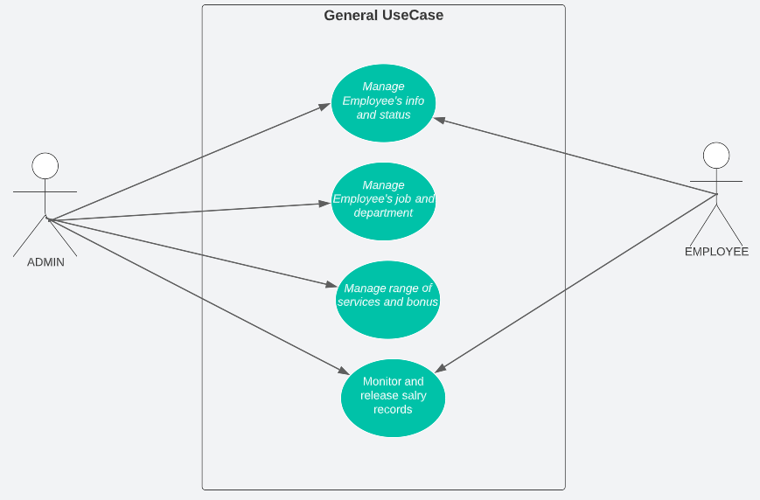

SEQUENCE DIAGRAM

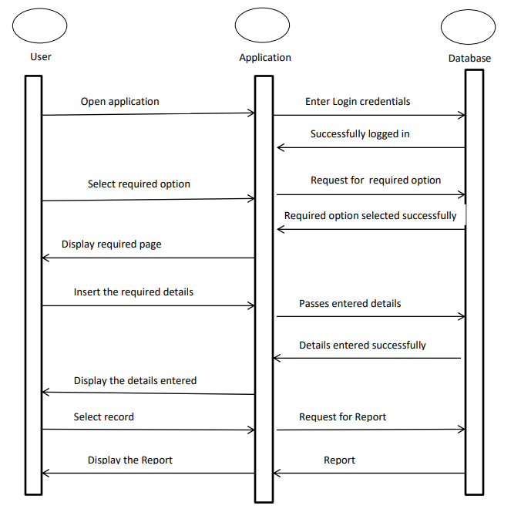

DATA FLOW DIAGRAM (DFD):

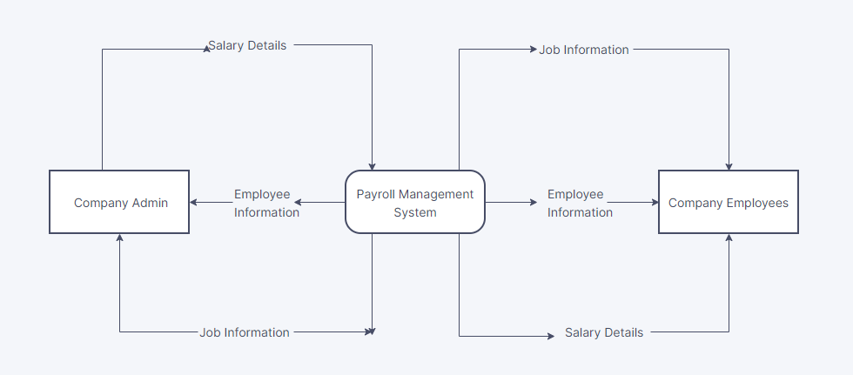

*Payroll Management System Project DFD Level 0*

ENTITY RELATIONSHIP DIAGRAM (ERD):

### 1.5.2) CONSTRAINTS:

These are the specifications that don't directly affect how the system works. When the system is designed, these should be taken into account as requirements.

The system was given the following constraints:

1) The user should be able to utilise login and passwords to access the system, and the administrator should register user information.

2) The system must be simple to comprehend and well-structured.

Feedback regarding any mistakes that occur should also go to the users.

3) The hardware platform that will be used to execute the system shouldn't have any restrictions.

4) Data integrity needs to be preserved in the event of a mistake or a system failure.

### 1.5.3) GUIDELINES

Mandatory conditions were covered in the section before that. The requirements in this part should be regarded as suggestions and recommendations to further improve the system's usefulness.

1. A user-friendly menu should be available for users to select from in the system.

2. The system ought to show the employee ID and the data that can be chosen from the drop-down menu on the forms.

3. The system's services should be accessible around-the-clock.

4. The system should be created in a way that makes adding new capabilities simple. It should be adaptable and simple to maintain.

# 2) PROBLEM STATEMENT

The most expensive component of a business is typically payroll. Paper-based employee attendance systems are ineffective and make it very simple for employees to game the system by putting false information on the sheet. The suggested solution is one of many automatic and adaptable systems that should be used to prevent the aforementioned problems.

**DISADVANTAGES**

The existing technique has the following drawbacks:

1. It is challenging to keep significant information in books

2. More manual work must be done to provide necessary reports.

3. Managing historical data, which requires a lot of storage to preserve all the books, ledgers, and other records from earlier years, is laborious.

4. Daily transactions must be entered into several books as soon as possible to avoid disagreements, which are particularly challenging.

## 2.1) PROPOSED SOLUTION:

The suggested system is a piece of software that eliminates the need for additional human record-keeping and report-generating time. This programme maintains the data in a central location that is simultaneously accessible to all users. Managing historical data in a database is extremely simple. The use of this application by the staff doesn't require any special training. They may easily utilise the tool that reduces the number of manual hours needed to complete routine tasks, improving performance. It is relatively simple to maintain the stocks of the various commodities because the data is centralised.

**ADVANTAGES**

It is cost effective as the user control the web application himself and does not go for professional service.

It saves time as it speeds up every aspect of the employee database management and payroll process with a range of automated features.

It is secure as the employee database and the payroll process is managed by the admin in house rather than sending private information to a third party.

Validating procedures and checks restrict user from making mistakes.

The software is easy to use and is user friendly so no expertise is required.

The calculations are automated so no chance of error.

# 3) FEASIBILITY STUDY

The feasibility research stage of the software development process is crucial. It makes it possible for the developer to evaluate the thing they're doing. It refers to the product's feasibility research in terms of the product's results, operational use, and technical assistance needed for implementation.

The feasibility study must be conducted after the project's scope has been determined. In essence, it involves remembering the points below.

## 3.1) Making software to fulfil the scope:

The scope was met by this software. As there are no data involved in the system, the file processing and behaviour of this project have already been recognised and quantified. This software's processing is quite easy because it was created in C-sharp language with DotNet Framework and is thoughtfully divided into many functions based on demand.

## 3.2) technically feasible:

Technically, this software is very doable. This software is particularly concerned with equipment specification, and it will successfully meet practically all of the admin's needs. The technical requirements for this system could range greatly, but they might include:

1. The ability to create output in a specific amount of time.
2. Response time in specific circumstances.
3. The capacity to process data at a specific rate.

As a result, the fundamental data input and output are recognised. The proposal is therefore technically feasible and can be simply built out.

## 3.3) State of Art:

Since the project is Windows-based and employs a highly contemporary and widely used method, it falls very much within the state of the art.

In addition, it is incredibly user-friendly and modern. It also functions as middleware, placing itself solely in front of the user and the file. Therefore, it is a wholly state-of-the-art project.

## 3.4) Financially Viable:

The initiative has excellent financial viability. This software's implementation and development costs are affordable for any college.

Additionally, it needs some instruction before use. Therefore, the cost of training may be disregarded, and this software has plenty of resources. The amount of labour and additional labour costs are also reduced. Therefore, it is indeed financially possible.

1. Time Based: In contrast to manual system management, any report may be generated with only one click. Maintaining historical data is too difficult in a manual method; it is simpler with this system. When compared to a manual system, the time needed to check reports or create new information is quite short. Therefore, from this perspective, this project is doable.
2. Cost Based: To manage the instrument, no special expenditure is necessary. The tool can be used by staff with no special training. Investment is only necessary once, during installation.

## 3.5) Resources:

As previously suggested, training is inexpensive and the resources are freely accessible. Situations may occasionally emerge when it may not be so simple. An individual who is utterly unprepared to use a computer system may incur training costs, and a very tiny organisation may run into problems if they must buy a computer, install the system, and pay other costs.

# 4) DESIGN DOCUMENT

## 4.1) SOFTWARE REQUIREMENTS:

1. Database: ORACLE PL/SQL developer

(*Version 7.1.5.1398*

*31.63558 - Unlimited user license*

*Windows Vista (64-bit) 6.2 Build 9200*)

1. Server: Chrome
2. Front end: ASPX, C#, CSS, HTML (*Knowledge*)
3. Editor: Microsoft Visual Studio Community 2019*(Version 16.11.21)*

## 4.2) HARDWARE REQUIREMENTS:

It is recommended that the minimum configuration for clients is as appended below: Suggested Configuration of Windows clients:-

1. Microprocessor : Pentium-4 class processor, 2.2 GHz
2. Ram: 1GB of RAM.
3. Hard Disk : 10 GB on installation drive which includes

500 MB on system drive

1. CD ROM Drive: 52 X CD ROM Drive.

## 4.3) DATABASE DESIGN:

### 4.3.1) the total number of Database tables that have been used in this project is 5.

* Transactional components: These components are helpful for documenting the transactions that the system does. These components handle all of the information regarding deliveries, inwards, etc.
* Components of the data dictionary: are used to store the important data, such as employee information, administrative information, employee information, leave applications, salary reports, etc.
* General components: These components are used to hold general data like login or sign-up information, among other things.

### Department Master Table:

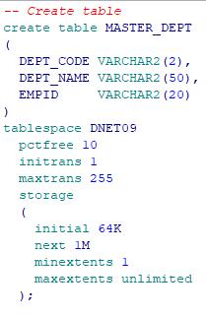

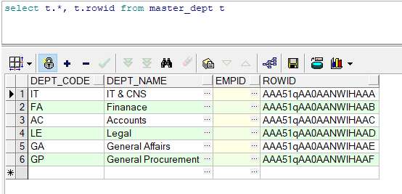

### Employee Management Table

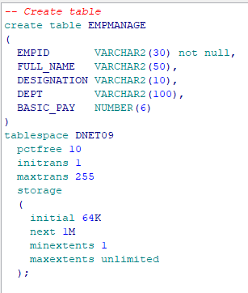

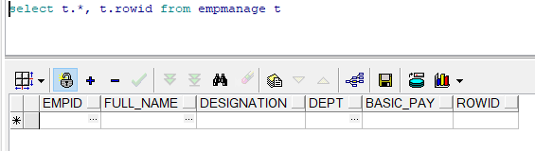

### Employee Salary Table:

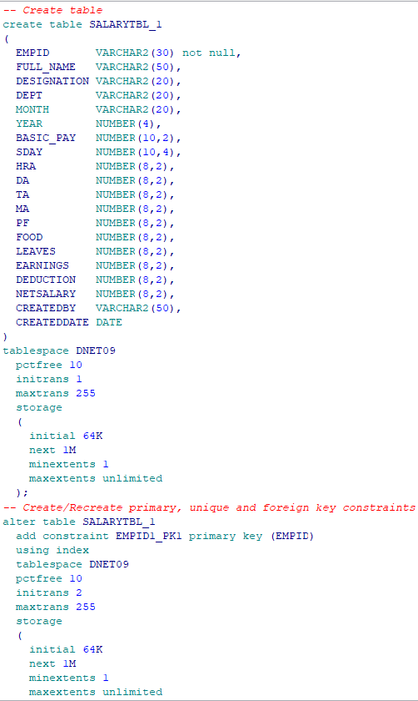

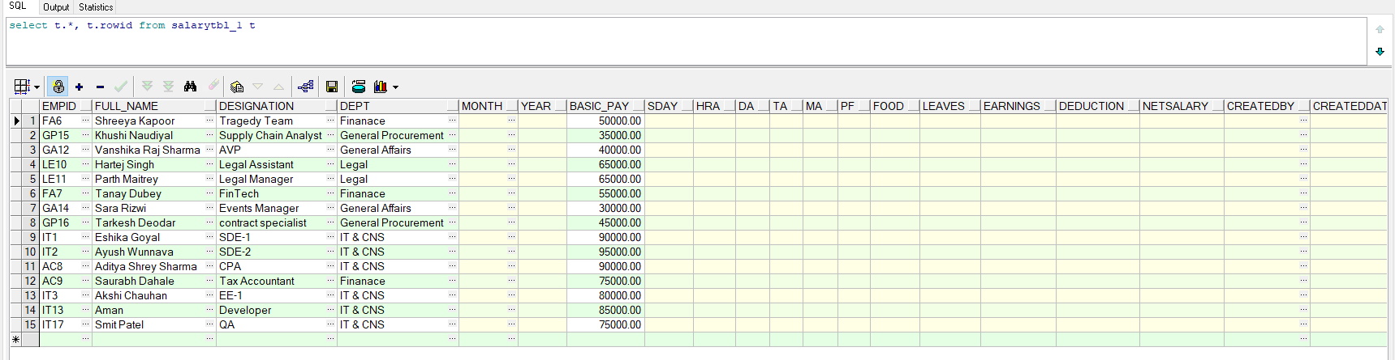

### Employee/Admin Leave table (Apply and Approval)

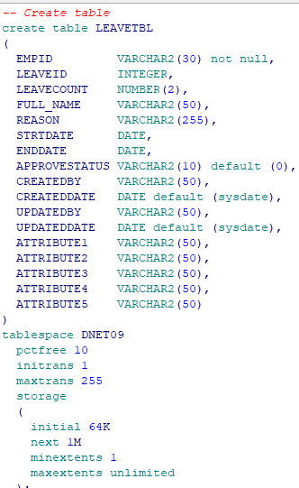

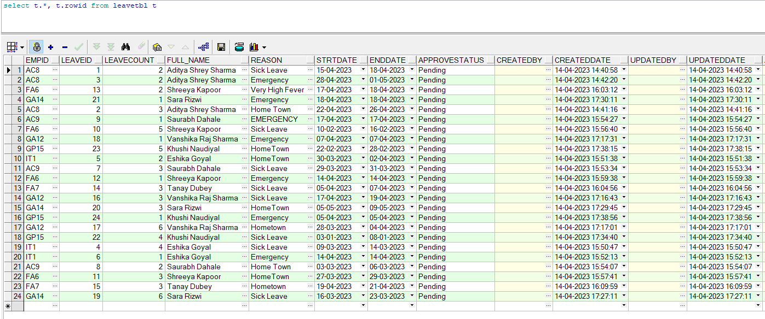

### Sign Up Table

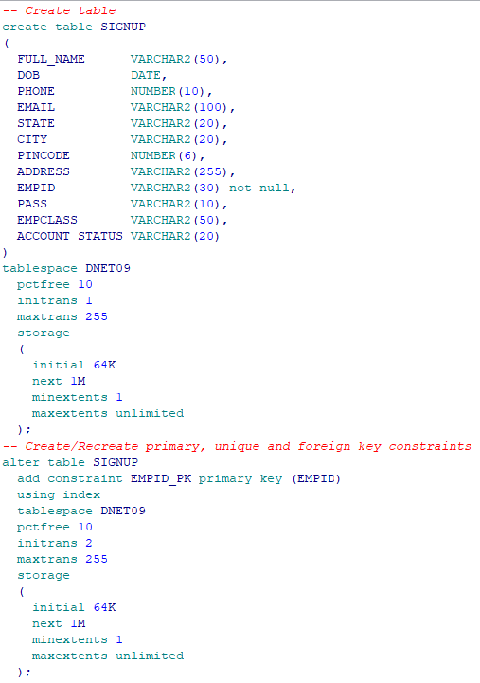

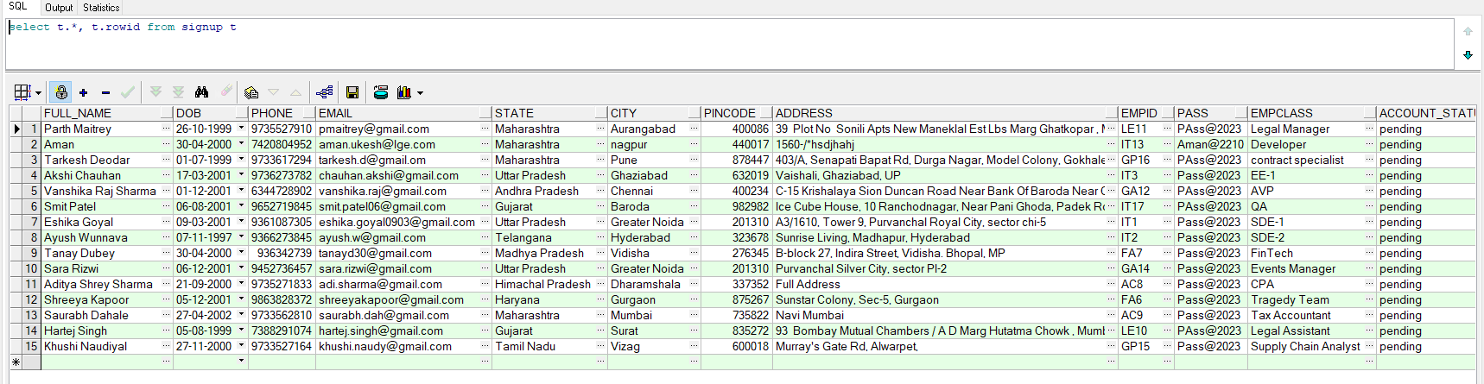

## 4.4) SYSTEM ANALYSIS

### 4.4.1) System Design:

**A) Users:**

The major functionality of this product is divided into two categories.

1. Administrative User Functions.

2. Normal User Functions.

**A.1) Admin Functions**

Administrators can perform the following task:

* Update and Delete the Users.
* Make their status Active, Pending, De-active.
* Approve the Leave application of employees from different departments.
* Generate the salary for the employee and upload them on the portal.
* Can view the information about the employee.
* Download the individual PDF of each employee, or can download the excel sheet for all the employees.

A.2) **Normal users can perform the following task**

* View the details of Employees of the Company.
* Can apply for leave by selecting start-to date and giving a reason
* Can update their Information
* Can download their Salary Report
* Print Salary Slip

# 5) MODULES

Following a thorough study, the System was determined to have the following modules.

## 5.1) EMPLOYEE INFORMATION MODULE:

This module maintains all of the data that relates to the people who work for the company as its employees. It makes it very simple for the administrator to add a new employee record to the database and to view a tabular list of all the employees from which he can select and edit a specific employee. The administrator can remove a worker from the list and print the employee report with the click of a single button. The ability to do all of the above is greatly increased.

## 5.2) ADMINISTRATOR MODULE:

It is used to handle the application's user information. There are two sorts of users. Administration User The administrator can check the list of users, add new users, and remove existing users from the list. It enables the printing of user reports by sending a print request to the printer.

## 5.3) LEAVE MODULE:

This Module will help the employee to apply for his/her leave whenever required and the no. of days the leave has been taken will be calculated automatically and be displayed in a textbox.

## 5.4) APPROVAL MODULE:

This module contains the functions for the administration where the person responsible for approving the leaves will be able to see all the leave application of all employee from each department and using the checkbox as a selecting method the admin will be able to either approve or reject the leave.

## 5.5) MANAGEMENT MODULE:

In this module the admin can manage the details of the employee, by updating or deleting the employee, change the status of the employee to, ‘Active’, ‘Pending’, ‘De-Active’.

## 5.6) SALARY MODULE:

In this module the admin can generate the salary of the employee using the basic pay per month. Basic pay is automatically getting filled via backend of each employee and from that salary generated will contain HRA, MA, TA, DA, earnings, tax deduction and finally the Gross net amount monthly.

In this, the admin can generate salary for every employee and then download them in the form of PDF individually or export the data in an excel file.

# 6) FRONTEND SCREENS

## 6.1) HOME PAGE:

This page enables the user to login based on the employee class which is sub-divided in 2 types the “ADMIN” and “EMPLOYEE”.

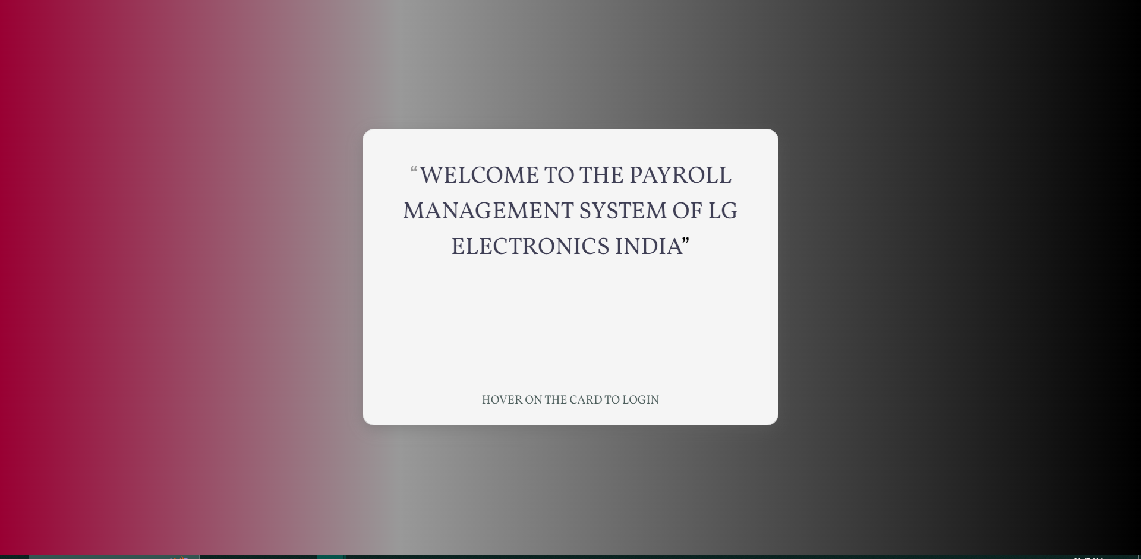

After Hovering:

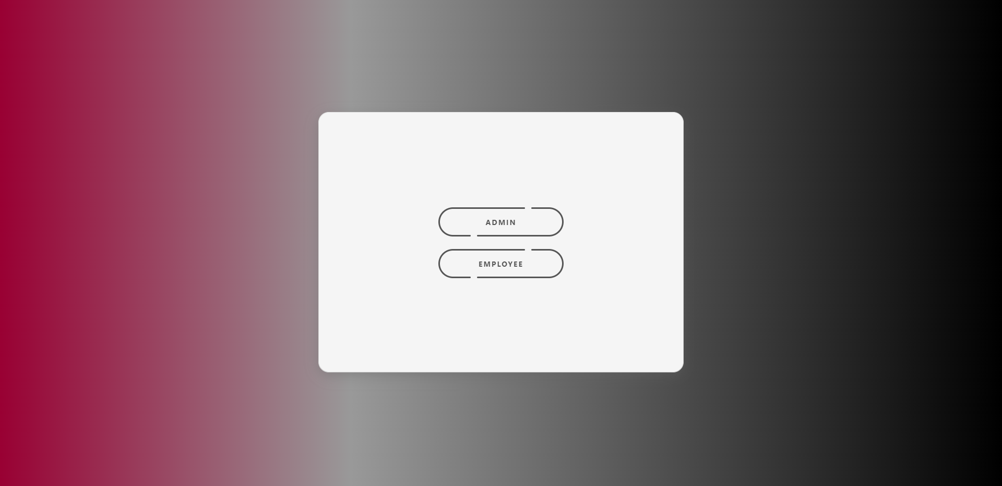

## 6.2) LOGIN PAGE (Employee):

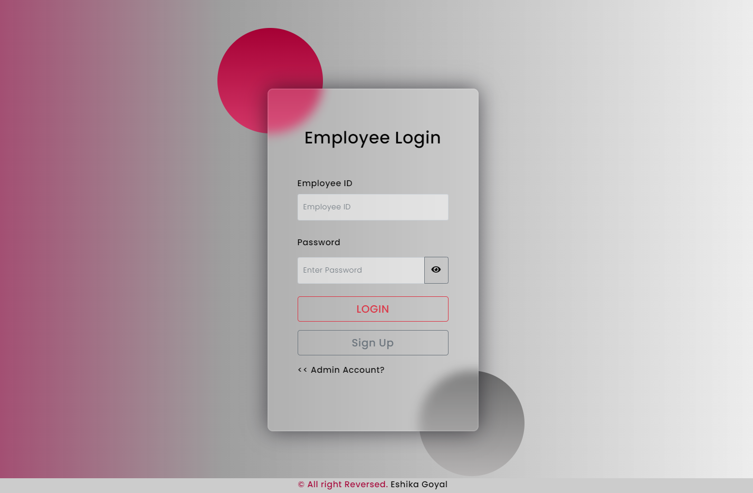

* Checking for the validations for wrong password or username
* Hovering on the password eye will enable you to show your password

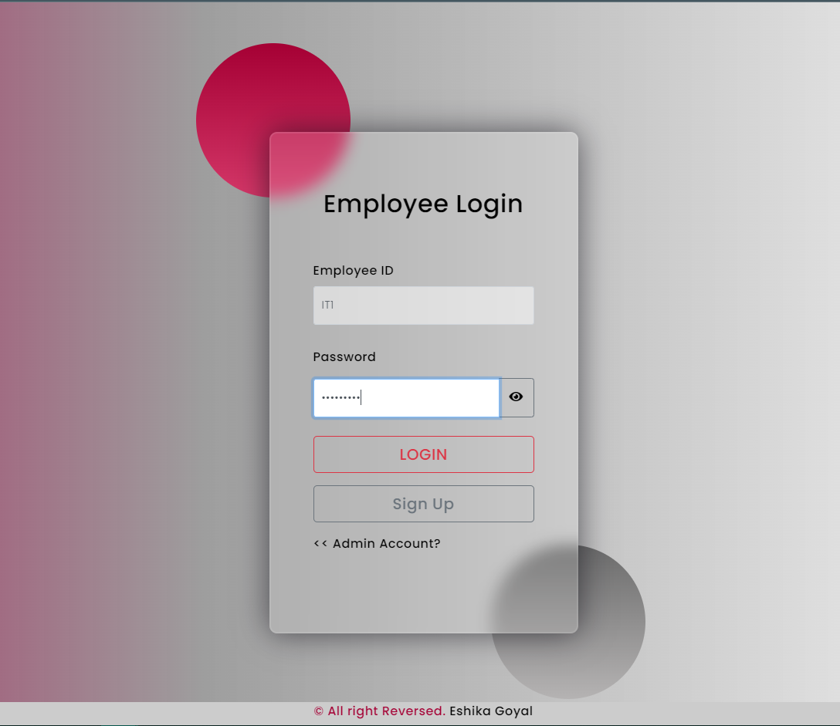

* An alert will be popped up

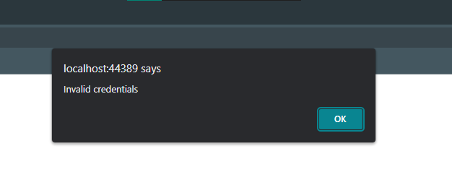

## 6.3) EMPLOYEE SIGNUP PAGE:

* If the employee has already signed in the popup will tell him/her saying ‘User already Exists’ else you can Sign-in to the portal

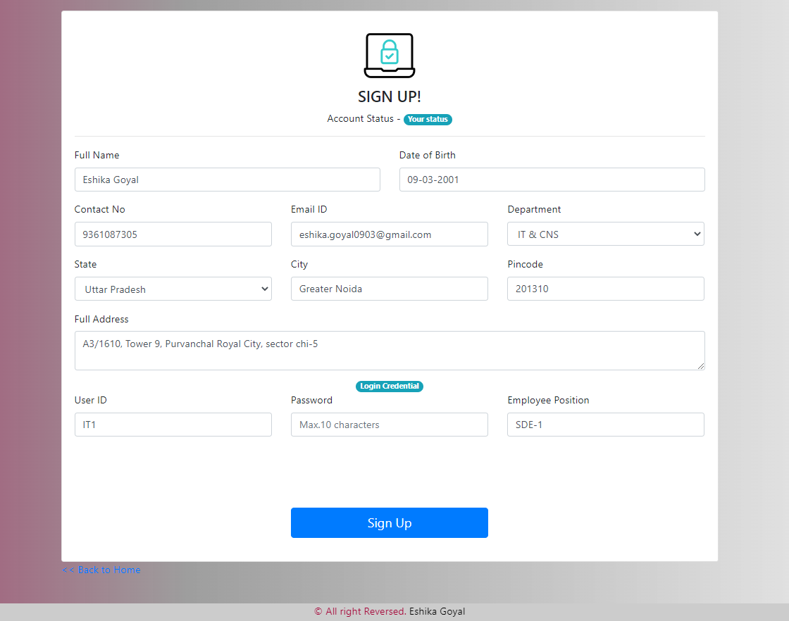

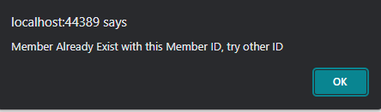

* The employee registration ID will be automatically created once they select their department, so that there is no false registrations.

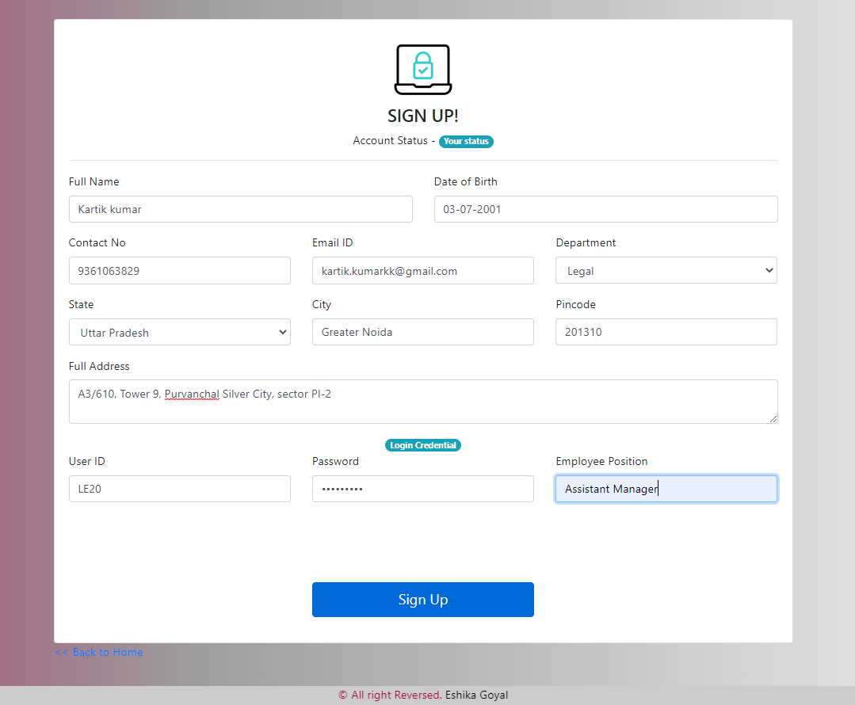

* Auto submit in the backend:

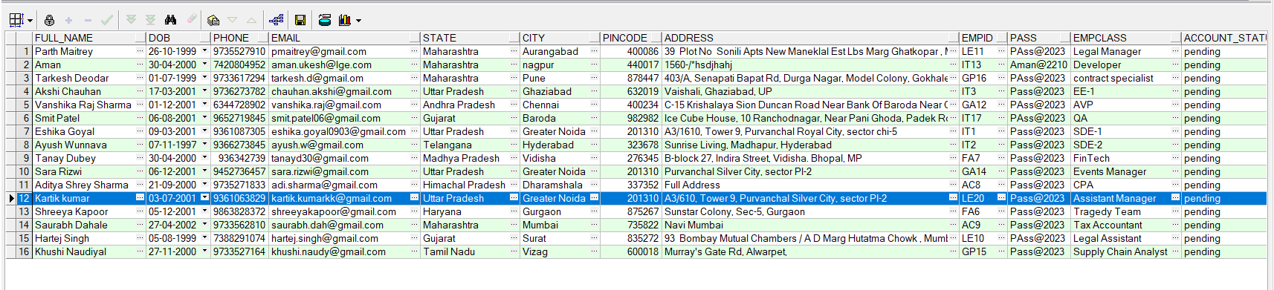

## 6.4) EMPLOYEE DASHBOARD:

Each tab will be re-directed to the designated pages.

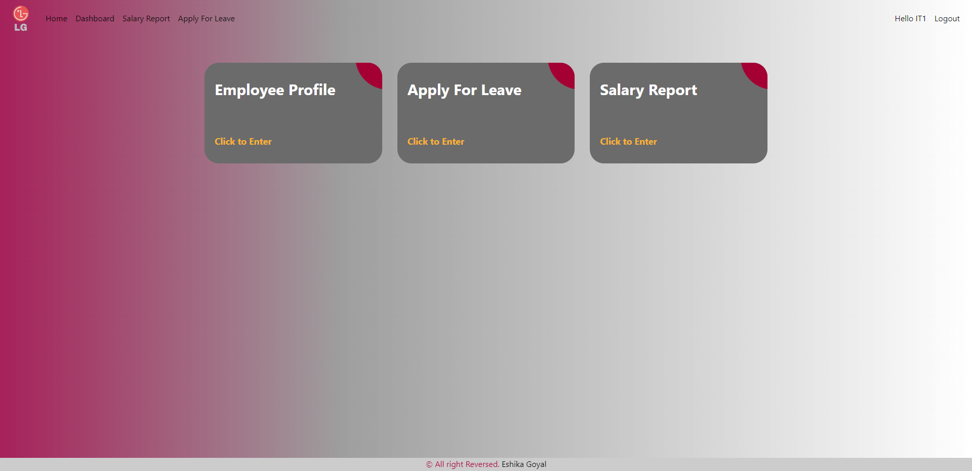

## 6.5) EMPLOYEE PROFILE PAGE:

In this page the employee can fill in his basic pay for every month accordingly and the this data will be backed-up in the backend

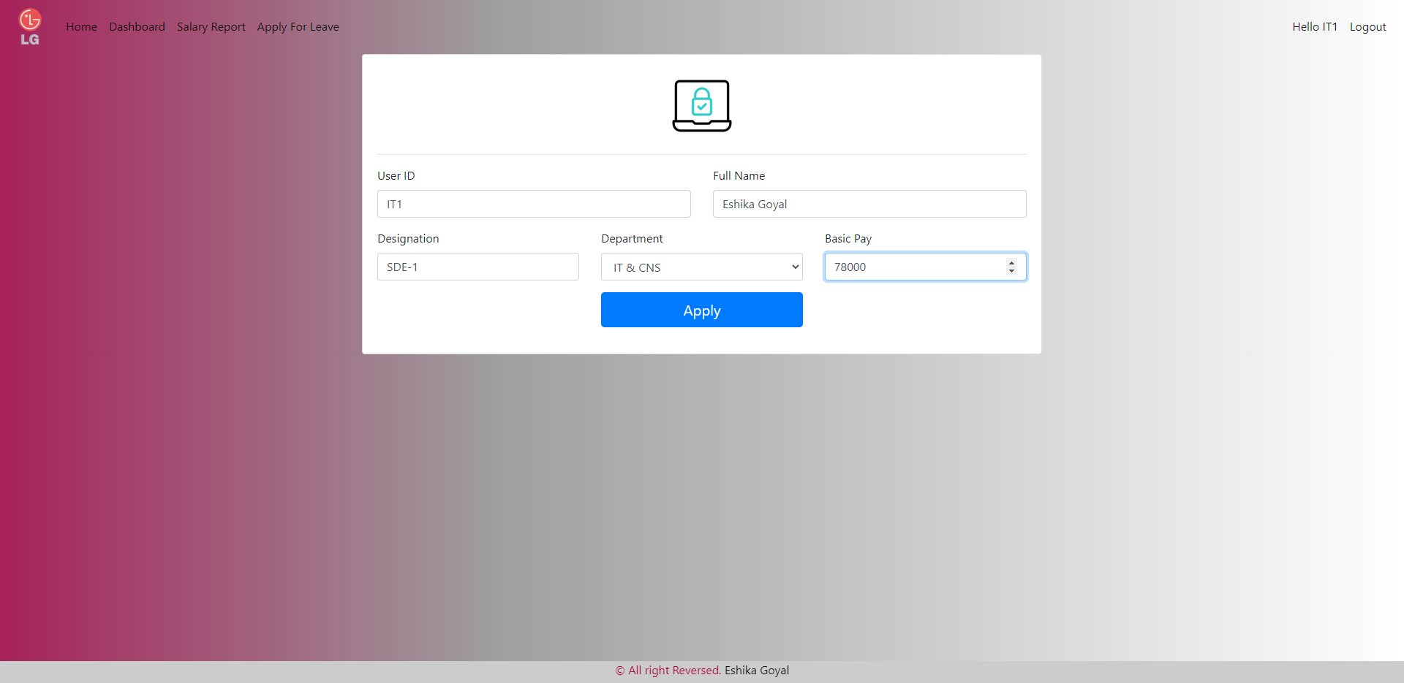

## 6.6) APPLY FOR LEAVE PAGE:

* In this page the employee can apply for the leave by choosing from and to date and giving the acceptable reason.
* After applying, the information will be displayed on the Gridview so the employee can recheck his/her leave and wait for the admin to approve.
* It has alerts too for not selecting dates in past, and the leaves are automatically calculated.
* If there is a public holiday or a holiday given by office including the weekends, the leave will not be counted.
* I have also provided the delete button so that the leave can be easily omitted.

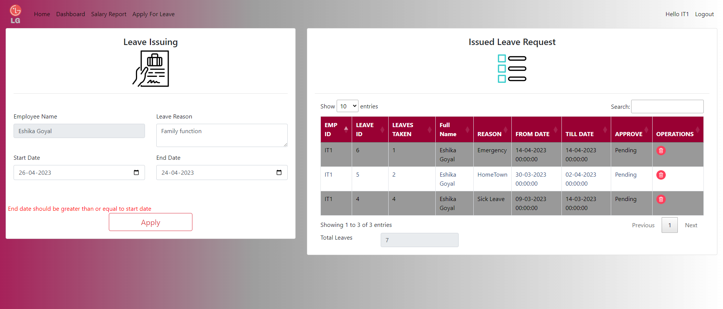

* After Applying the leave:

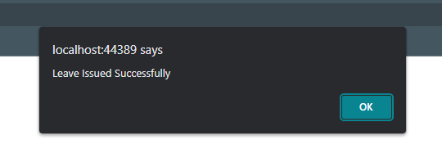

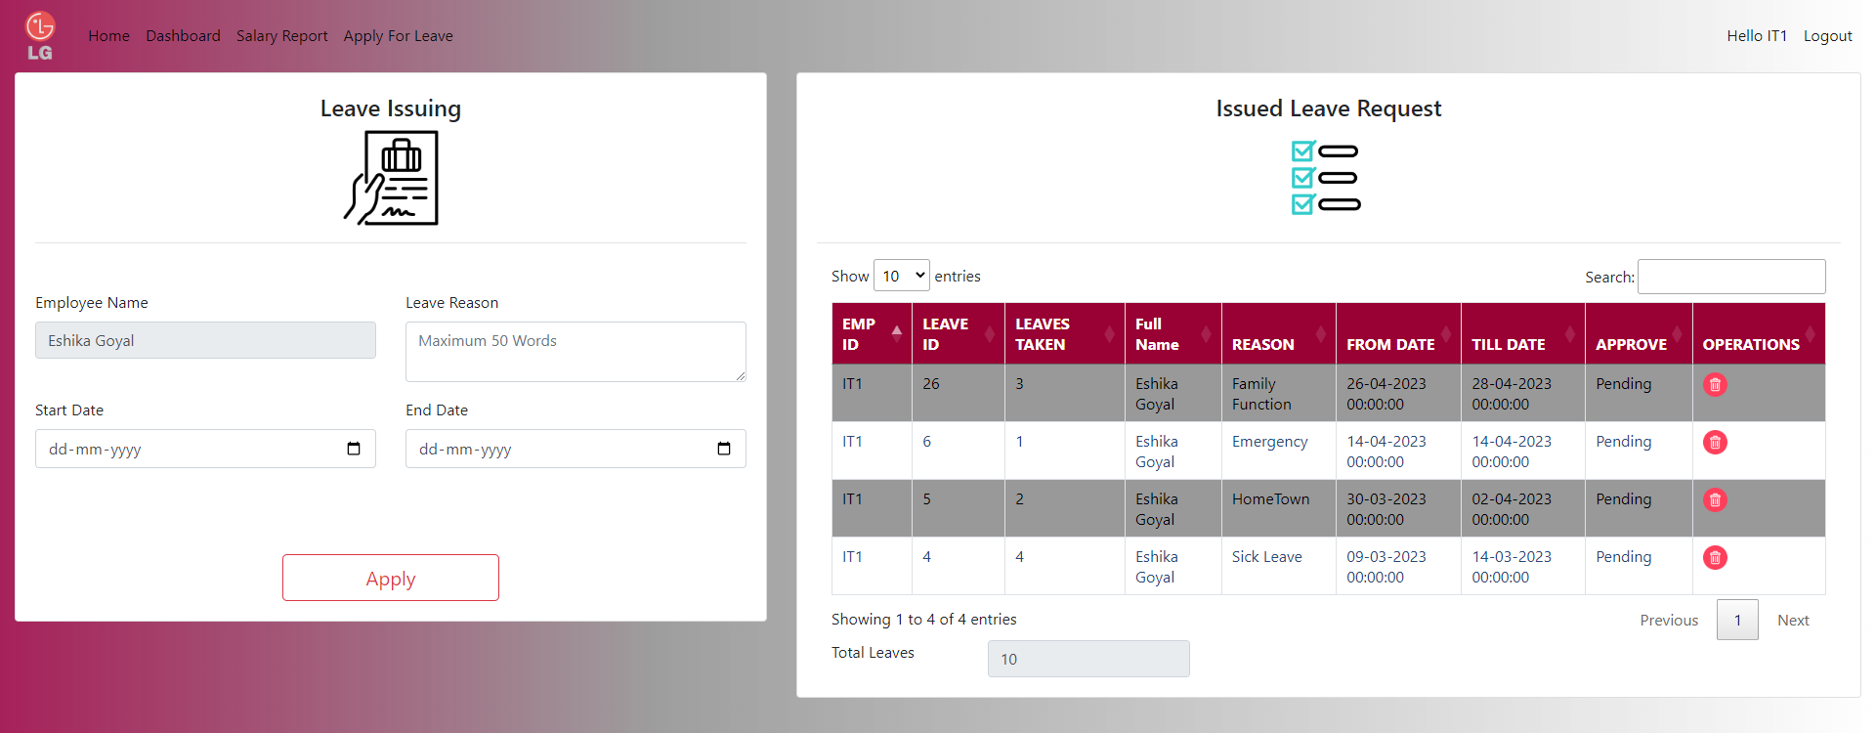

* After Deleting the leave:

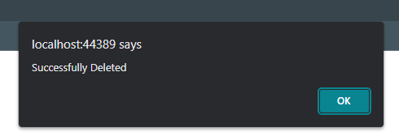

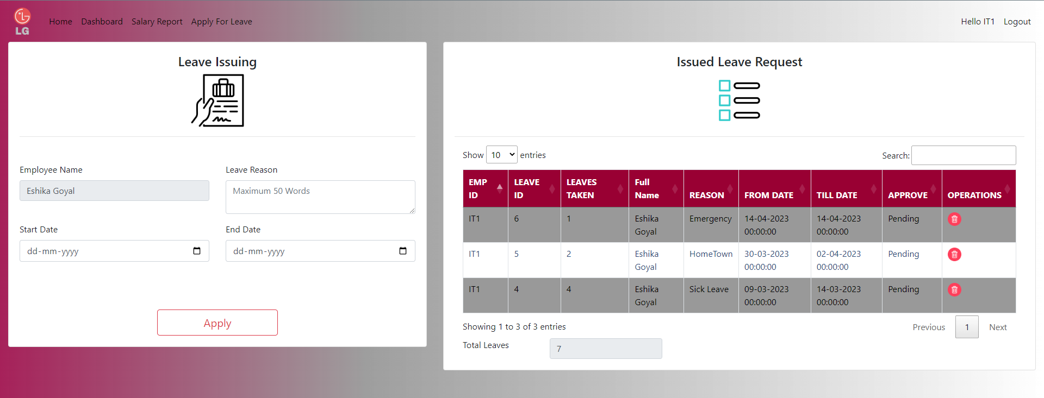

## 6.7) EMPLOYEE SALARY PAGE:

* In this page, the employee can see his/her monthly salary generation, with all the earnings and the deduction.
* It is represented in the Gridview format and with the help of the last column the employee can download the individual salary slip, or if they want, they can generate an excel file which will accommodate the employee’s salary from each month.

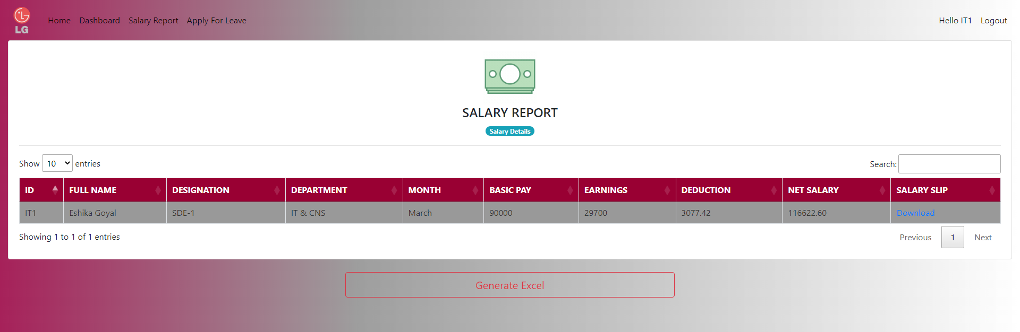

The PDF format:

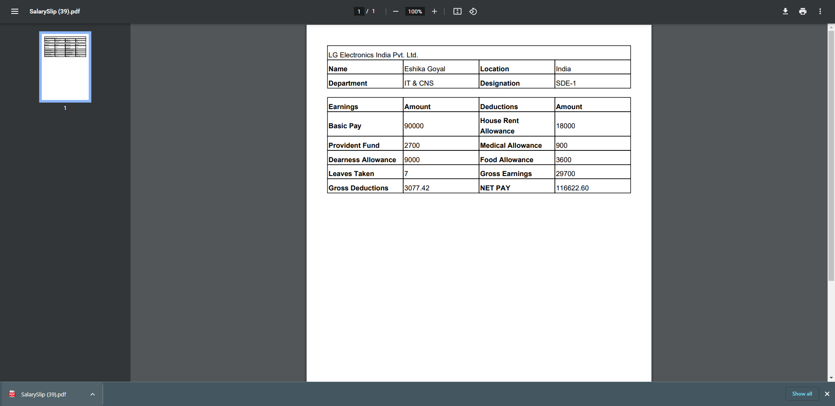

## 6.8) LOGIN PAGE (Admin):

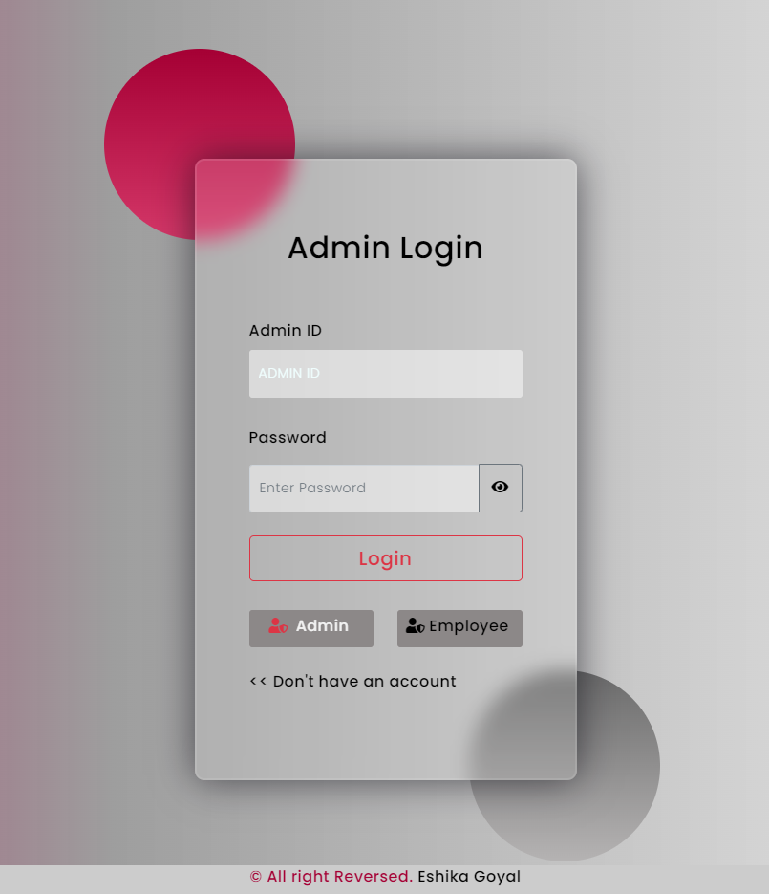

## 6.9) ADMIN SIGNUP PAGE:

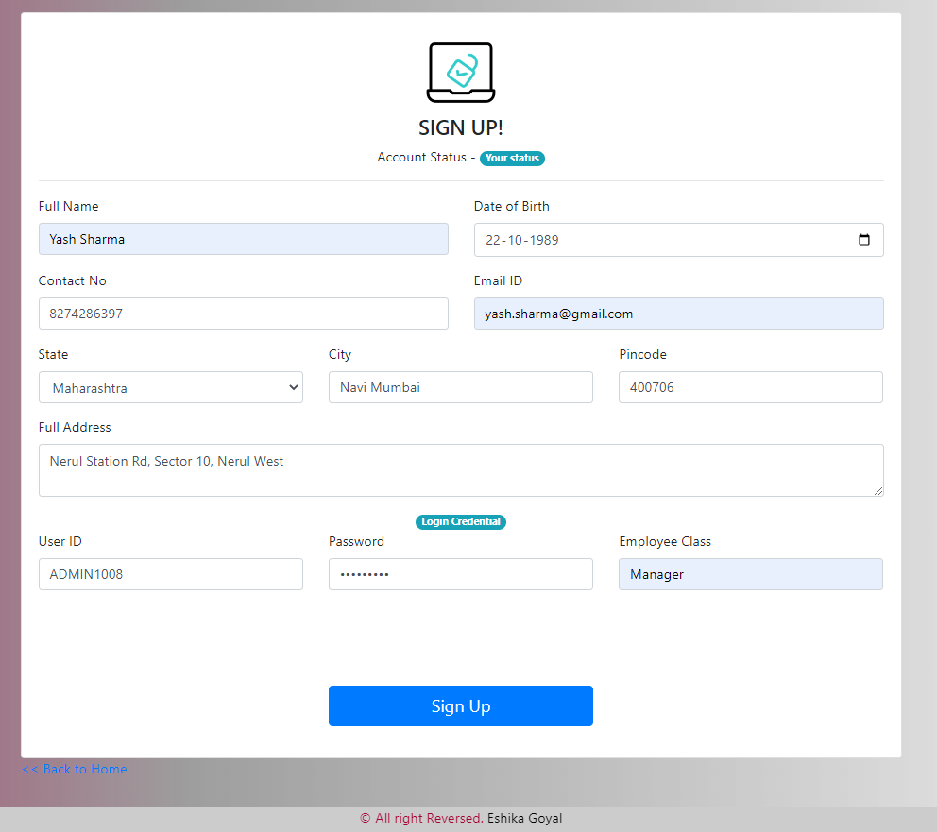

Auto submit in the backend:

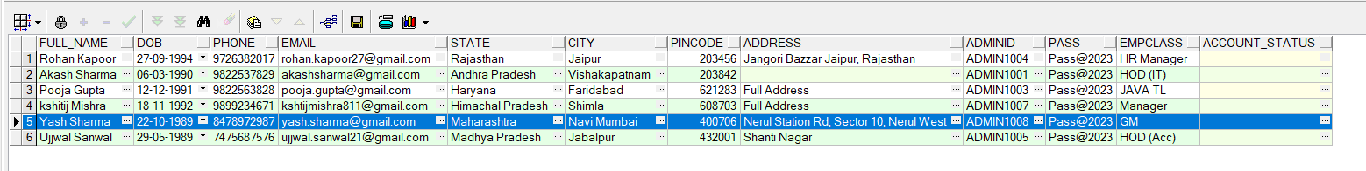

## 6.10) ADMIN DASHBOARD:

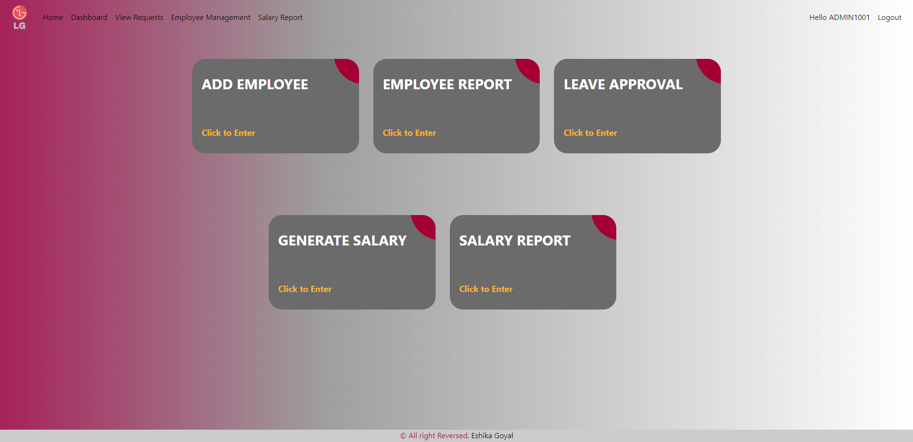

## 6.11) EMPLOYEE INFORMATION PAGE:

In this page the Admin can delete or update the data of the employee by simply putting in the registration number and then clicking the GO button, which will automatically fill in the details of the employees and only the necessary changes will be made.

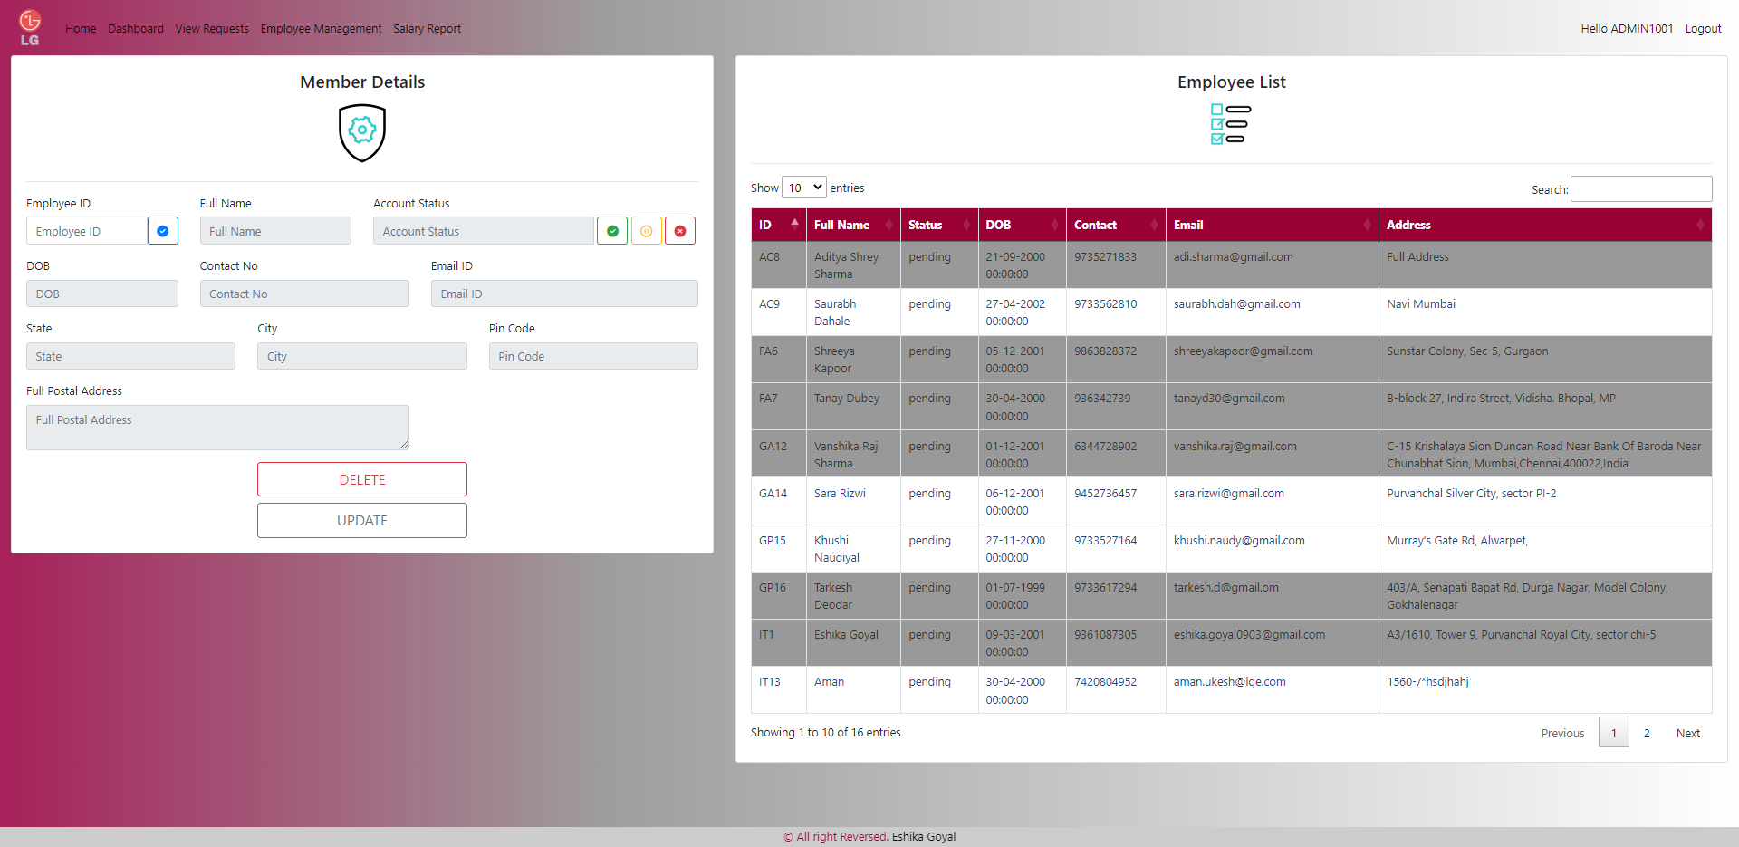

* Filling in the Registration number and then clicking GO

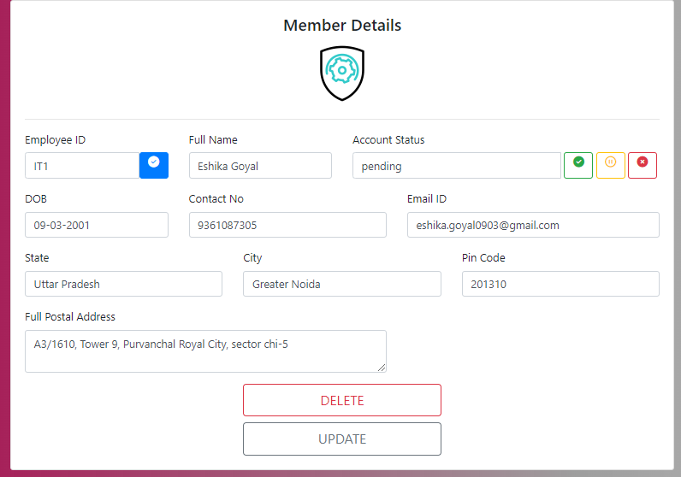

* The Account status can be changed by clicking on these buttons to make the employee ‘Active’, ‘De-active’, and ‘Pending’.

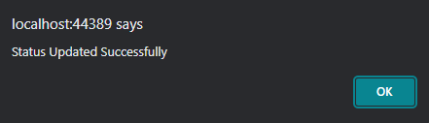

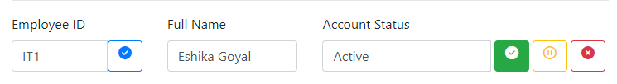

* To delete an Employee Information or to update, we can use the given buttons.

## 6.12) APPROVE LEAVE REQUEST VIA ADMIN

* In this module, the admin can see the leave request from every employee from each department
* The admin can approve or reject the leaves by checking the check boxes given on the last column of the Gridview.

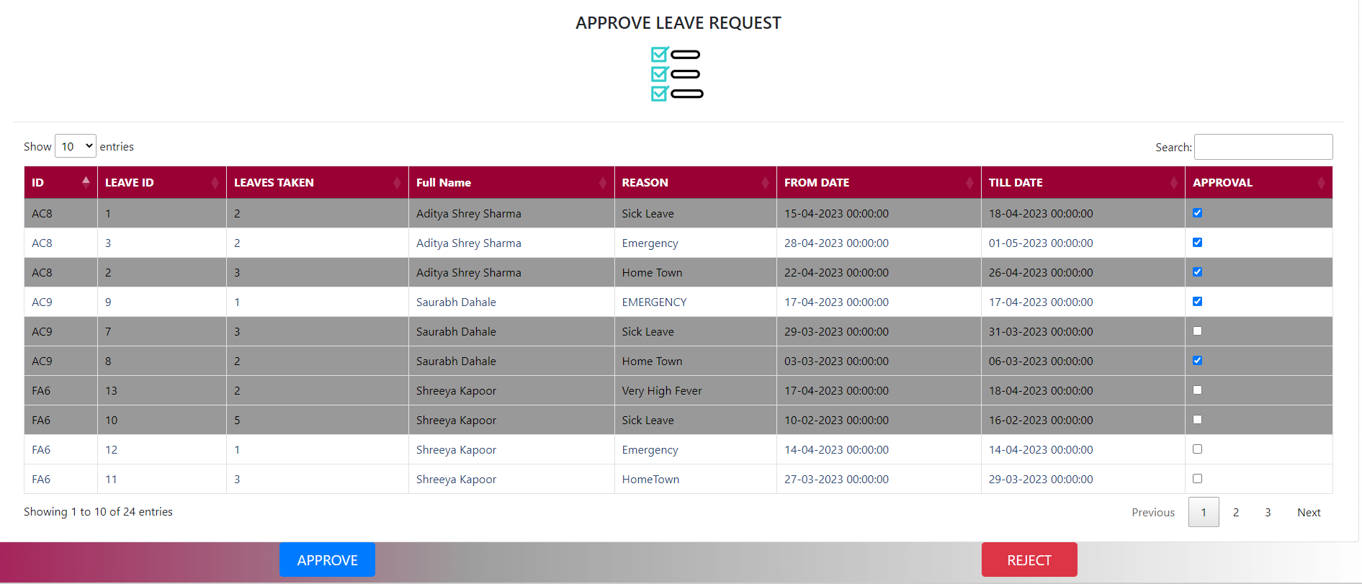

Here you can see the status of the leaves have been updated from pending to Approved and Rejected after admin approved the status from their side.

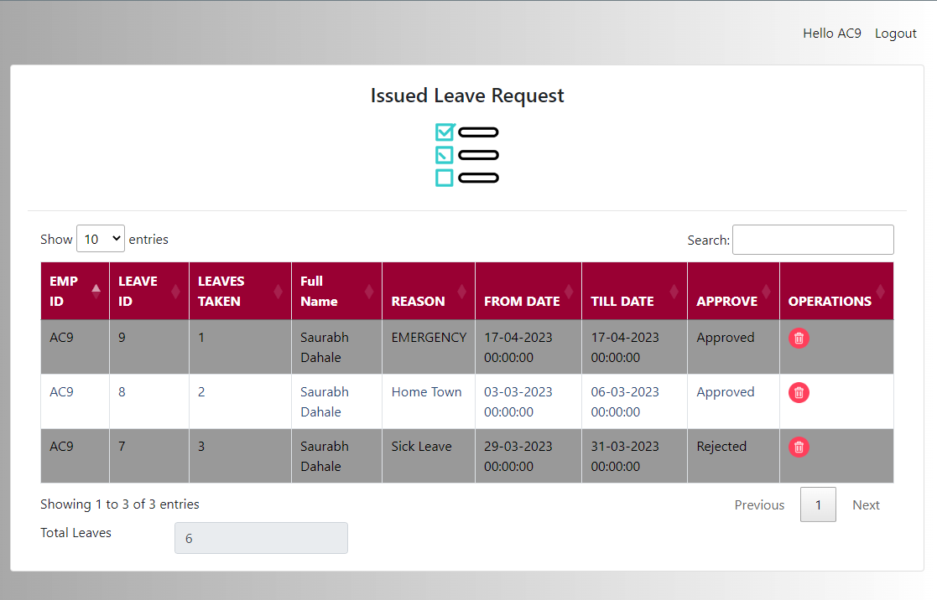

## 6.13) GENERATE SALARY

* Here the admin can generate the salary of the employee
* The basic pay of the employee will be automatically filled in the textbox from the backend, each employee will be filling at the start of each month by a form.
* The reason behind this- the basic pay of the employee can differ month to month including bonus or and other deduction which will be intimated by the employee by the form.

STEPS TO OPERATE:

1. Fill in the employee registration number, choose the month and year and then click on the GO button.

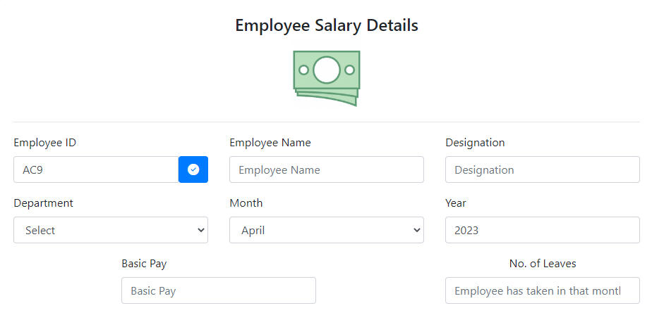

1. The information of the employee will be filled automatically from the data taken from the backend.

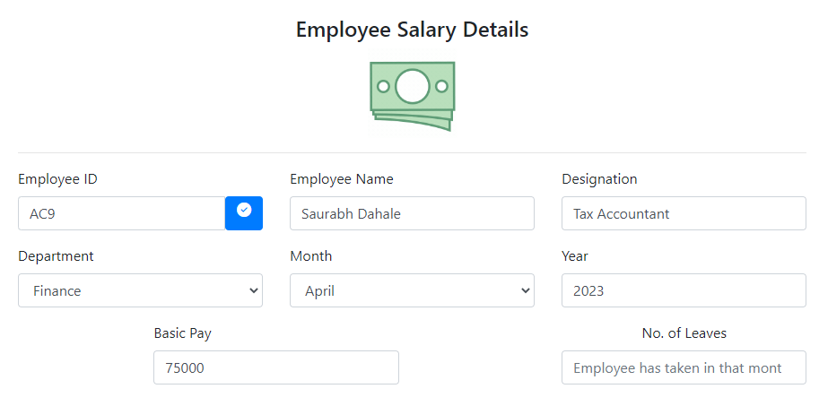

1. To generate the Net salary fill in the total no. of leaves the employee has taken in that month and then click on the button “Generate Salary”

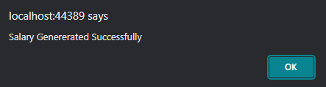

1. The Total Salary:

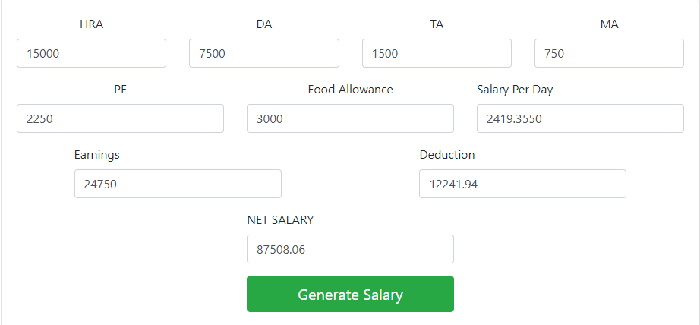

## 6.14) THE SALARY REPORT PAGE

This page offers the Gridview look of all the employees and their salary report

The admin can download the pdf as well as generate excel by clicking the buttons given.

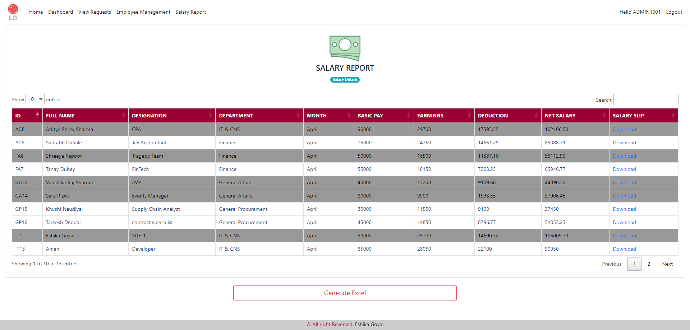

Excel File Created:

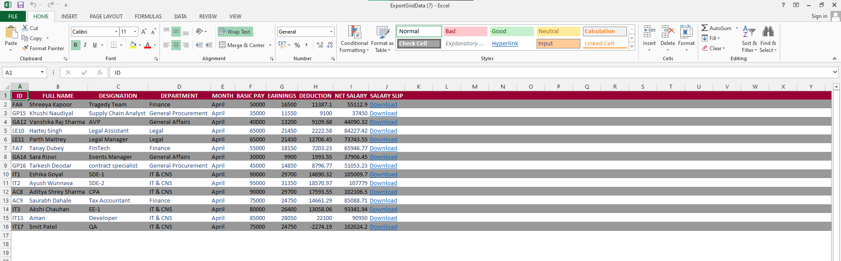

## 6.15) PROFILE PAGE

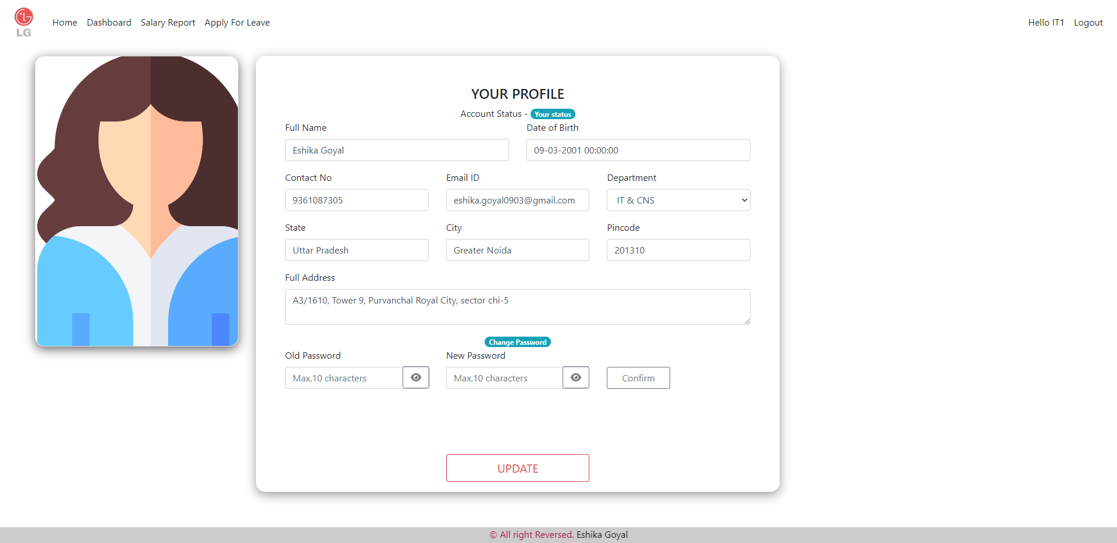

Employee can change the password from the official to personalised one.

From the Profile card, people can go to their socials.



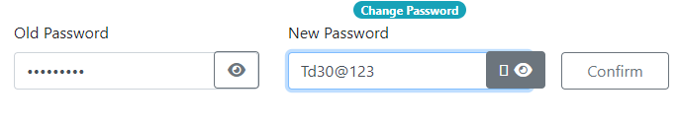

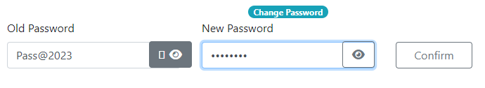

# 7) TESTING

The error that was left over from the earlier step must also be found during testing. It is the process of looking things through with the goal of identifying mistakes. Giving a programme a set of test inputs and watching to see if it behaves as predicted is testing a programme. If the programme crashes, the circumstances of the crash are recorded for troubleshooting and corrections.

Level of Testing:

Before the system was put into use, extensive testing was done to get rid of any bugs that might have been there. A certain level of testing was used to conduct the test.

These are what they are:

* Unit Testing
* Code walkthrough
* Integrated Testing
* Validation Testing
* Output Testing
* System Testing

## 7.1) Unit Testing:

Given that the inaccuracy is precise, testing at the unit level is absolutely necessary. Unit testing is the isolation testing of several parts or modules of a system. Testing is carried out to ensure that every component of the software operates correctly and produces the required results when given the inputs.

## 7.2) Code walkthrough:

In this phase of testing the code is thoroughly checked for discrepancies that may occur in the code such as redundancy of code, deviations in the naming convention etc.

## 7.3) Validation Testing:

The programme was fully constructed as a package at the conclusion of the integration testing, any interface issues had been found and fixed, and a final round of software validation testing had started. Here, we test the system in a way that the customer might reasonably anticipate; the system was tested in accordance with the system requirement specification.

## 7.4) Integrated Testing:

All of the code modules are assembled and tested for intended outputs during integrated testing. The integrated and tested modules have undergone unit testing. This testing phase combines every module. After then, the entire programme is put to the test.

Integrated test plans created during the system development's design phase are used as a guide for the integrated testing. For the upcoming testing procedures, all systemic errors have been fixed. The tested module produces the anticipated results.

## 7.5) Output Testing:

Conduct it by feeding a sample valid input image, comparing the ratio found in the compressed output image with the predicted ratio, and then repeating the process. The input image determines how accurate the result will be.

## 7.6) System Testing:

In system testing, the complete system, including all forms, code, module, and class modules, is tested as a whole. After undergoing integrated testing, the entire system is put to the test in various settings, and it is discovered that there were no runtime errors. Consequently, the system will function properly in all environments once testing is complete.

**TESTING PHASE:**

### 7.1) Unit Test Specification for Login Form (ADMIN/EMPLOYEE):

|  |  |  |  |
| --- | --- | --- | --- |
| **Sr.No** | **Test Condition** | **Expected Result** | **Test Result** |
| 1. | Valid user id and password is entered | Main form is displayed | As Expected |
| 2. | User id or password is invalid | Invalid user message box is displayed | As Expected |
| 3. | If User id or password is not entered | Enter the login details message box is displayed | As Expected |

### 7.2) Unit Test Specification for Registration Form (ADMIN/EMPLOYEE):

|  |  |  |  |
| --- | --- | --- | --- |
| **Sr.No** | **Test Condition** | **Expected Result** | **Test Result** |
| 1. | Collection of Personal Information | Collected and saved in the backend DB | As Expected |
| 2. | Department selection via dropdown | Selected and showed in form | As Expected |
| 3. | Employee ID generated automatically | Custom ID cannot be created and employee cannot change | As Expected |
| 4. | Set manual password | Password set and showed in DB | As Expected |
| 5. | Choose employee designation | Designation gets chosen | As Expected |
| 6. | Save the form | Record successfully saved in the backend DB | AS Expected |

### 7.3) Unit Test Specification for Salary Update:

|  |  |  |  |
| --- | --- | --- | --- |
| **Sl.No** | **Test Condition** | **Expected Result** | **Test Result** |
| 1. | All Info can be seen | Auto load from backend DB | As Expected |
| 2. | Monthly Basic-Pay updated | Can be done manually | As expected |
| 3. | Data goes to salary table | From the Apply button, data goes to DB | As Expected |

### 7.4) Unit Test Specification for Leaves Form:

|  |  |  |  |
| --- | --- | --- | --- |
| **Sr.No** | **Test Condition** | **Expected Result** | **Test Result** |
| 1. | Employee ID visible in Textbox | ID called from session variable | As Expected |
| 2. | Leave ID generated automatically | ID visible from the sequence created | As expected |
| 3. | Fill in Start date | Date selected from the auto calendar | As Expected |
| 4. | Fill in End date | Date selected from the auto calendar | As Expected |
| 5. | Multiline comment box for reason of leave | Reason can be stated in max 50 words | As Expected |
| 6. | End date should be greater than start date | Alert pops up when the action is performed | As Expected |
| 7. | Leaves grid view | Leave code, type and no of leaves gets updated in the grid | As Expected |
| 8. | If delete link is clicked in the grid | Confirmation message box is displayed. On confirmation, record is deleted | As Expected |
| 9. | Total number of leaves are calculated | Showed in the Textbox | As Expected |
| 10. | Leaves including public holidays and office leaves are deducted automatically | The count is shown perfectly | As Expected |

### 7.5) Unit Test Specification for View Leave Request Form:

|  |  |  |  |
| --- | --- | --- | --- |
| **Sl.No** | **Test Condition** | **Expected Result** | **Test Result** |
| 1. | Search by | It searches the leaves requested on the basis of date of request, ID and status | As Expected |
| 2. | Date of request | Displays when the leave was requested | As expected |
| 3. | Employee ID | Displays the staff no who has requested the leave | As Expected |
| 4. | Status | Displays the status of the request | As Expected |
| 5. | View leave request grid view | ID, leave type, etc. is updated in the grid | As Expected |

### 7.6) Unit Test Specification for Salary Report:

|  |  |  |  |
| --- | --- | --- | --- |
| **Sr.No** | **Test Condition** | **Expected Result** | **Test Result** |
| 1. | All Information is displayed in Gridview | Obtained from the backend DB | As Expected |
| 2. | Monthly Salary calculated | Done by the help of the formulae | As expected |
| 3. | Salary slip downloadable | It can be downloaded from the download option provided in the Gridview | As Expected |
| 4. | Salary slip can be generated in the excel file | It can be generated from the excel option provided below | As Expected |

### 7.7) Unit Test Specification for Employee Profile:

|  |  |  |  |
| --- | --- | --- | --- |
| **Sl.No** | **Test Condition** | **Expected Result** | **Test Result** |
| 1. | Employee information is entered | Auto-updated from the DB | As Expected |
| 2. | Old password is entered | It is updated from change password table | As expected |
| 3. | New password is entered | It is updated from change password table | As Expected |
| 4. | Confirm password is entered | New password is re-entered | As Expected |
| 5. | Save Changes is clicked | Record is stored and password changed successfully message box is displayed | As Expected |

### 7.7) Unit Test Specification for Editing the employee (ADMIN):

|  |  |  |  |
| --- | --- | --- | --- |
| **Sr. No** | **Test Condition** | **Expected Result** | **Test Result** |
| 1. | Employee ID is entered to get auto load of info | Auto-updated from the DB | As Expected |
| 2. | Status of employee to be updated | Active, Pending, De-active buttons are provided to update the status | As expected |
| 3. | Updating the employee | Update the employee by selecting the ID | As Expected |
| 4. | Deleting the employee | Delete the employee by selecting the ID | As Expected |
| 5. | Employee details can be seen in the Gridview | Stored and searchable in the Gridview | As Expected |

### 

### 7.8) Unit Test Specification for Approve Form:

|  |  |  |  |
| --- | --- | --- | --- |
| **Sr .No** | **Test Condition** | **Expected Result** | **Test Result** |
| 1. | Approve is clicked | The leave request gets approved | As Expected |
| 2. | Reject is clicked | Leave request gets rejected | As Expected |
| 3. | Checkbox is clicked | The checkbox corresponding to the ID will result in the action of approve or reject | As Expected |
| 4. | Search available | Present in the Gridview | As Expected |

### 7.9) Unit Test Specification for Generating Salary:

|  |  |  |  |
| --- | --- | --- | --- |
| **Sr .No** | **Test Condition** | **Expected Result** | **Test Result** |
| 1. | Employee can be searched | Employee info can be loaded from the backend DB | As Expected |
| 2. | Total salary can be calculated with the basic salary | With the formula provided in the backend, the salary can by generated. | As Expected |
| 3. | Checkbox is clicked | The checkbox corresponding to the ID will result in the action of approve or reject | As Expected |
| 4. | Search available | Present in the Gridview | As Expected |

### 7.10) Unit Test Specification for Generating Salary:

|  |  |  |  |
| --- | --- | --- | --- |
| **Sr .No** | **Test Condition** | **Expected Result** | **Test Result** |
| 1. | All Information is displayed in Gridview | Obtained from the backend DB | As Expected |
| 2. | Monthly Salary calculated | Done by the help of the formulae | As expected |
| 3. | Salary slip downloadable | It can be downloaded from the download option provided in the Gridview | As Expected |
| 4. | Salary slip can be generated in the excel file | It can be generated from the excel option provided below | As Expected |

# 8) CONCLUSION

This project was created with the idea that it would only be utilised by the admin. It is designed to be used in smaller organisations with fewer people. The administrator can add, modify, update, and delete all employee data in his organisation in accordance with the requested specification. Departments may be deleted or added by the administrator. For the employees, the admin can also specify specified pay grades. The administrator can quickly and simply see the necessary records whenever he wishes. The employee gets compensated on a monthly basis. The administrator could submit accurate data thanks to the many incorporated validations.

# 9) IMPORATANT FEATURES OF PROJECT COVERED

1. Integrated Accounting
2. Recording Files and Payslips
3. Reporting in the Payroll Software
4. Keeping track of earnings
5. Tax management done easily
6. Easy to Pass on Information and Updates
7. Makes Compliance Easier
8. Easy to Set Up
9. Automated Systems
10. Easy to Integrate

# 10) FUTURE SCOPE OF THE WORK

1. I would like to implement a regular backup mechanism to back up the employee database to avoid disasters.
2. SMS and Email services will be provided for reminders and communication.
3. Payroll to be handled by different level of authorisation in the administrative roles.
4. Increase security for protecting data sensitivity.
5. Will try to shift this to a cloud-based service for securing the data and prevent data loss.